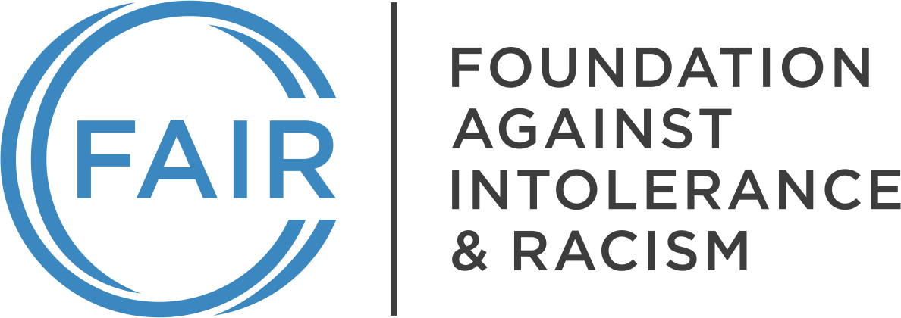

Month, Day, Year

Title/Name
Institution Name
Address
Dear [recipient name]:

The Foundation Against Intolerance & Racism (FAIR) is a nonpartisan, nonprofit organization dedicated to advancing civil rights and liberties and promoting a common culture based on fairness, understanding, and humanity. We have tens of thousands of members nationwide, including in [State]. Our website, fairforall.org, can give you a fuller sense of our identity and activities.

As a FAIR member and a parent/stakeholder within the [school name/district name] (the “District”/“School”), I write today in order to raise important considerations that must be accounted for in advance of the upcoming school year. Recent case law strongly supports our concerns, and we would encourage [school name/district name] to pause and reconsider any policy that compels students or staff to use, or to refrain from using, particular pronouns.

On November 6, 2025, the full U.S. Court of Appeals for the Sixth Circuit, sitting en banc, ruled in Defending Education v. Olentangy Local School District Board of Education, No. 23-3630 (6th Cir. Nov. 6, 2025), that a public school district could not discipline students under its anti-harassment policy for declining to use a classmate's preferred pronouns. The en banc court held that the district's policy amounted to viewpoint discrimination and compelled speech in violation of the First Amendment, explaining that the district had failed to show the use of biological pronouns would materially and substantially disrupt the educational environment or infringe on the rights of others. The decision reversed a three-judge panel and a district court that had both ruled in the school district's favor, and it now stands as one of the most significant recent statements on students' First Amendment rights not to be compelled to affirm a contested viewpoint on gender identity.

We find it obviously antithetical to education for a student to be required to ascribe to any set of thoughts or beliefs. While concrete facts are well-understood and demonstrated clearly, beliefs, theories, ideas, and feelings can be personal or religious, are sometimes merely aspirational, and are always up for debate. The very purpose of education is to offer students, especially young students like those taught at [School name/district name], the opportunity to learn about, explore, and build upon newly discovered ideas. In no case should any student, regardless of age, be required to affirm a mere belief.

A [teacher] requiring the students in [class] to announce their preferred pronouns via [verbal expression in class OR in writing via a required worksheet] is compelled speech and violates the First Amendment to the United States Constitution. See West Virginia State Board of Education v. Barnette, 319 U.S. 624 (1943) (holding that Jehovah's Witness students who have a religious objection to reciting the Pledge of Allegiance cannot be required to do so due to protection granted by the First Amendment).

The act of announcing an individual's pronouns requires an inherent affirmation of the underlying idea that one's gender identity can be different from one's biological sex, an idea disputed by many, and one that is commonly rejected on the basis of many different sincerely held religious beliefs. The right to be free from government interference with one's sincerely held religious belief is protected by the Establishment Clause of the First Amendment and by several United States Supreme Court decisions.

When a public school or one of its teachers, which is a government entity and therefore a state actor, compels a student to say something that affirms an idea that runs counter to their own sincerely held religious belief, the First Amendment guarantee of freedom of speech is violated. Hurley v. Irish-American Gay, Lesbian & Bisexual Group, 515 U.S. 557, 573 (1995); see also Wooley v. Maynard, 430 U.S. 705, 714 (1977) ("A system which secures the right to proselytize religious, political, and ideological causes must also guarantee the concomitant right to decline to foster such concepts."); Oliver v. Arnold, 3 F.4th 152, 162 (5th Cir. 2021) (public school teachers may not give assignments for the purpose of compelling students to assert specific ideals); Defending Education v. Olentangy Local School District Board of Education, No. 23-3630 (6th Cir. Nov. 6, 2025) (en banc) (school district policy compelling students to use classmates' preferred pronouns, or disciplining them for declining to do so, constitutes unconstitutional compelled speech and viewpoint discrimination).

As Justice Jackson famously stated, "If there is any fixed star in our constitutional constellation, it is that no official, high or petty, can prescribe what shall be orthodox in politics, nationalism, religion, or other matters of opinion or force citizens to confess by word or act their faith therein." Barnette, 319 U.S. at 642. While teachers should permit students to declare their pronouns if they so choose, they may not require them to do so and they likewise may not require students to use pronouns for their classmates that conflict with the students' own sincerely held beliefs.

Given this developing body of case law, it would be prudent for [School District Name] to review and, if necessary, revise any policy that compels students or staff to use particular pronouns, whether through direct requirement or through the threat of discipline under an anti-harassment or anti-bullying policy.

I urge the District/School to closely review its existing policies in advance of the new school year to ensure they provide faculty and staff with the tools necessary to ensure a positive experience for all students where their First Amendment rights are honored and safeguarded. Furthermore, I ask that you consider issuing a District/School-wide communication that delineates the District’s/School’s policies and plan for ensuring the maintenance of a safe learning environment that protects all students.

[NAME]
[Chapter Name, Title]
Foundation Against Intolerance & Racism

cc: [consider cc’ing all school board members, and any known attorneys representing the school board]

